**NETWORK ARCHITECTURE - 1**

**HOME WORK - 3**

**FALL 2016**

**SUBMITTED BY:**

**ANUSHA MALINENI**

**STUDENT ID: 16233382**

**1. Consider the network shown below. Suppose AS2 and AS3 are running OSPF for their intra-AS routing protocol. Suppose AS1 and AS4 are running RIP for their intra-AS routing protocol. Suppose eBGP and iBGP are used for the inter-AS routing protocol. Initially suppose there is no physical link between AS2 and AS4.**

**(a)** **Router 3c learns about prefix x from which routing protocol: OSPF, RIP, eBGP or iBGP?**

**(b)** **Router 3a learns about prefix x from which routing protocol?**

**(c)** **Router 1c learns about prefix x from which routing protocol?**

**(d)** **Router 1d learns about prefix x from which routing protocol?**

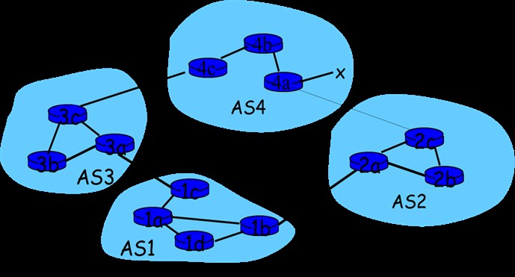

**Answer:**

Given that AS2 and AS3 are running OSPF for their intra-AS routing protocol, AS1 and AS4 are running RIP for their intra-AS routing protocol and eBGP and iBGP are used for the inter-AS routing protocol and there is no link between AS2 and AS4.

(a) Router 3c learns about prefix x from which routing protocol: OSPF, RIP, eBGP or iBGP?

**Router 3c learns about prefix x from eBGP routing protocol.** x is connected to AS4 and it is close to AS3 and is the only path to know about the prefix. Hence the Router 3c learns about x from eBGP protocol.

(b) Router 3a learns about prefix x from which routing protocol?

**Router 3a learns about prefix x from iBGP routing protocol.** As Router 3c learns about x from eBGP inter-AS routing protocol from AS4, Router 3a which is internally connected to Router 3c learns from iBGP inter-AS routing protocol.

(c) Router 1c learns about prefix x from which routing protocol?

**Router 1c learns about prefix x from eBGP routing protocol.** AS3 learns about x from AS4 through eBGP inter-AS routing protocol and in turn Router 1c which is a gateway router learns from AS3 through eBGP routing protocol.

(d) Router 1d learns about prefix x from which routing protocol?

**Router 1d learns about prefix x from iBGP routing protocol.** Though x is close to 1d through AS2, since there is no physical connection between AS2 and AS4, it routes through AS4 to AS3 and then to AS1. Router 1d learns about x from gateway router 1c through iBGP routing protocol.

**2. Consider the network shown below (the labels are the delay on the links).**

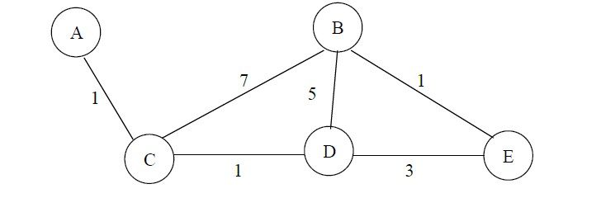

**Show the operation of Dijkstra’s (Link State) algorithm for computing the shortest path from C to all destinations.**

**Answer:**

|  |  |  |  |  |  |
| --- | --- | --- | --- | --- | --- |
| Step | N` | D(A) = p(A) | D(B) = p(B) | D(D) = p(D) | D(E) = p(E) |
| 0 | C | 1, A | 7, B | 1, D | ∞ |
| 1 | CD | 1, A | 6, D | -- | 4, D |
| 2 | CDA | -- | 6, D | -- | 4, D |
| 3 | CDAE | -- | 5, E | -- | -- |
| 4 | CDAEB | -- | -- | -- | -- |

The shortest path from C to all destinations is depicted as below.

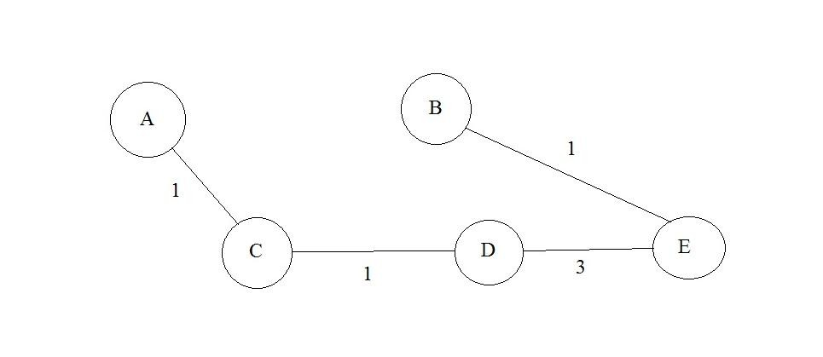

Forwarding table in C:

|  |  |
| --- | --- |
| Destination | Link |
| A | (C, A) |
| B | (C, D) |
| D | (C, D) |
| E | (C, D) |

**3. Consider the network shown below (the labels are the delay on the links)**

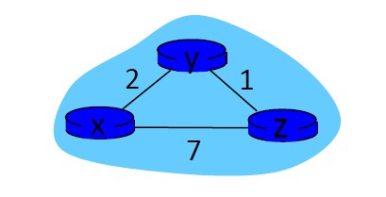

**(a) Show the operation of Distance Vector algorithm for computing the shortest path from node X, node Y, node Z to all destinations.**

**(b) Show the distance table that would be computed by the distance vector algorithm.**

**Answer:**

1. **Show the operation of Distance Vector algorithm for computing the shortest path from node X, node Y, node Z to all destinations.**

We know

Dx(y) = min{c(x,y) + Dy(y), c(x,z) + Dz(y)} = min{2+0 , 7+1} = 2

Dx(z) = min{c(x,y) + Dy(z), c(x,z) + Dz(z)} = min{2+1 , 7+0} = 3

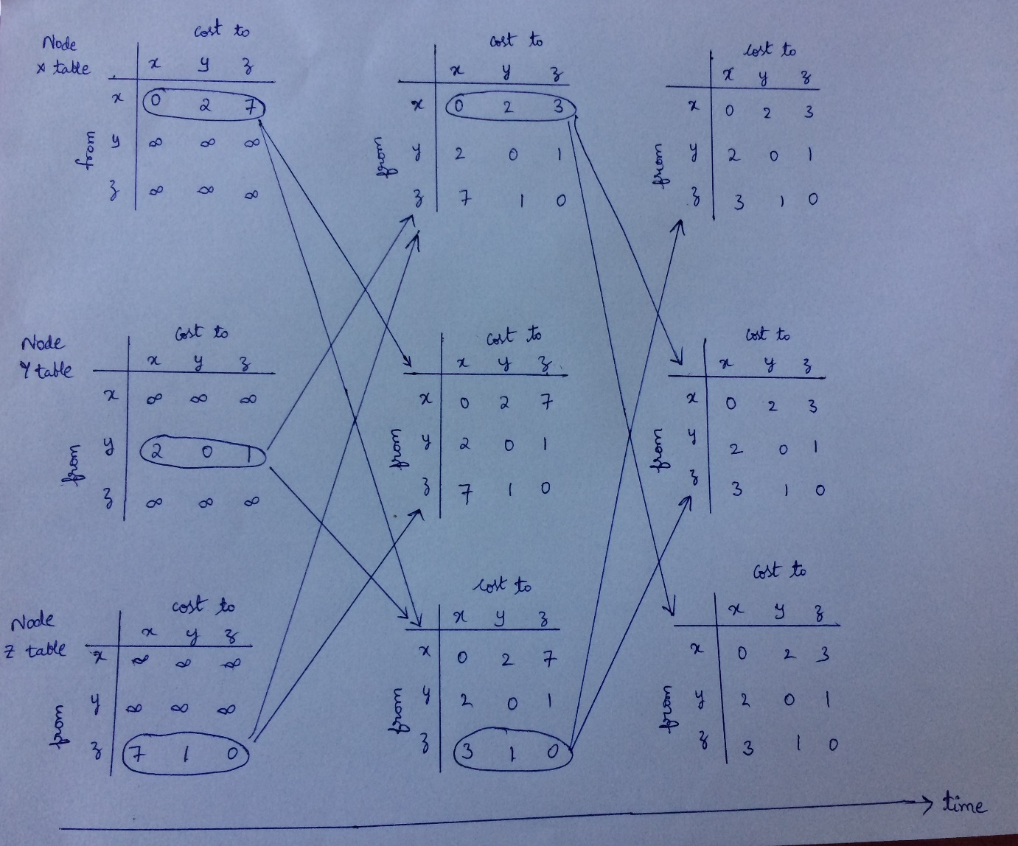

1. **Show the distance table that would be computed by the distance vector algorithm.**

|  |  |  |  |
| --- | --- | --- | --- |
| Node | To x | To y | To z |
| From x | 0 | 2 | 3 |
| From y | 2 | 0 | 1 |
| From z | 3 | 1 | 0 |

**Laboratory Homework**

**1. Select the first ICMP Echo Request message sent by the computer, and expand the Internet Protocol part of the packet in the packet details window. What is the IP address of the user's computer?**

**Answer**:

The IP address of the user’s computer is given by 192.168.1.102

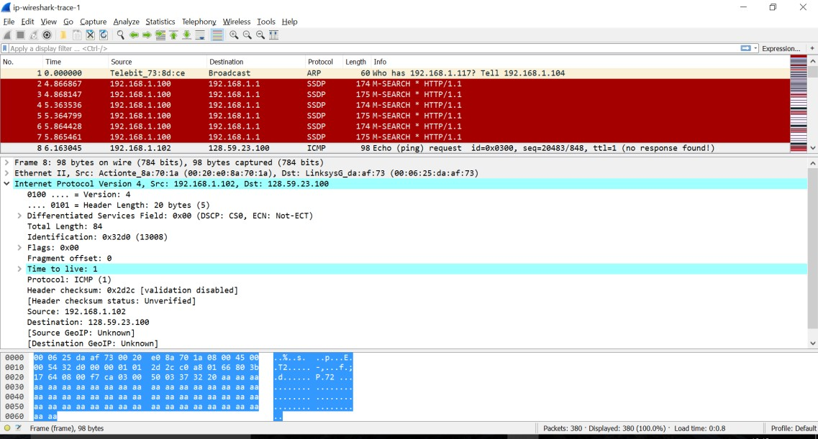

**2.** **Within the IP packet header, what is the value in the upper layer protocol field?**

Within the IP packet header, the value in the upper layer protocol field is 1.

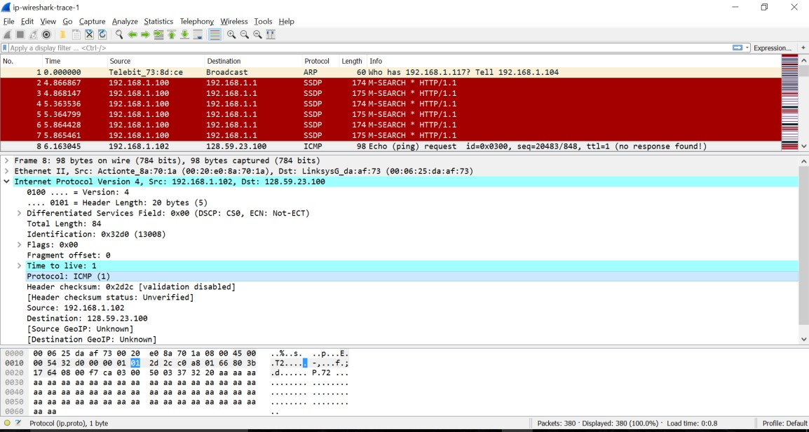

**3. How many bytes are in the IP header? How many bytes are in the payload *of the IP* *datagram*? Explain how you determined the number of payload bytes.**

**Answer**:

The header length is 20 bytes. The payload of the IP datagram is of length 84 bytes. The number of payload bytes is given by the difference between the payload of IP datagram and the header length = 84-20 = 64 bytes.

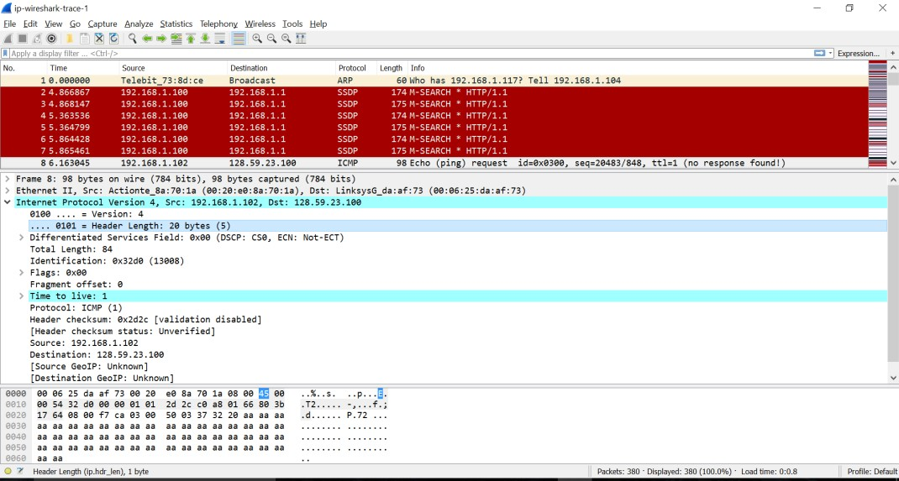

**4. Has this IP datagram been fragmented? Explain how you determined whether or not the datagram has been fragmented.**

**Answer**:

The IP datagram is not fragmented. This is known by the flags value of 0x00.

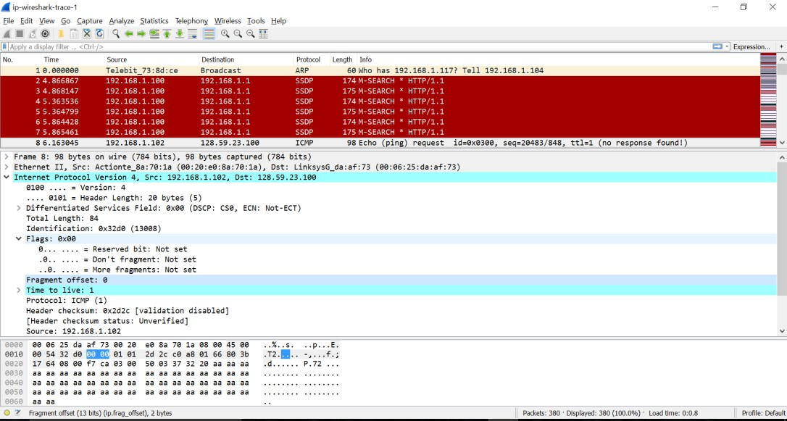

**5. Which fields in the IP datagram *always* change from one datagram to the next within this series of ICMP messages sent by the computer?**

**Answer**:

Let us consider the datagrams 368, 365 and 361

Datagram 368

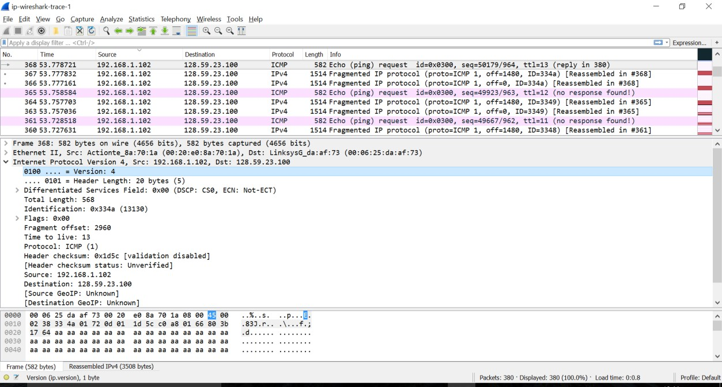

Datagram 365

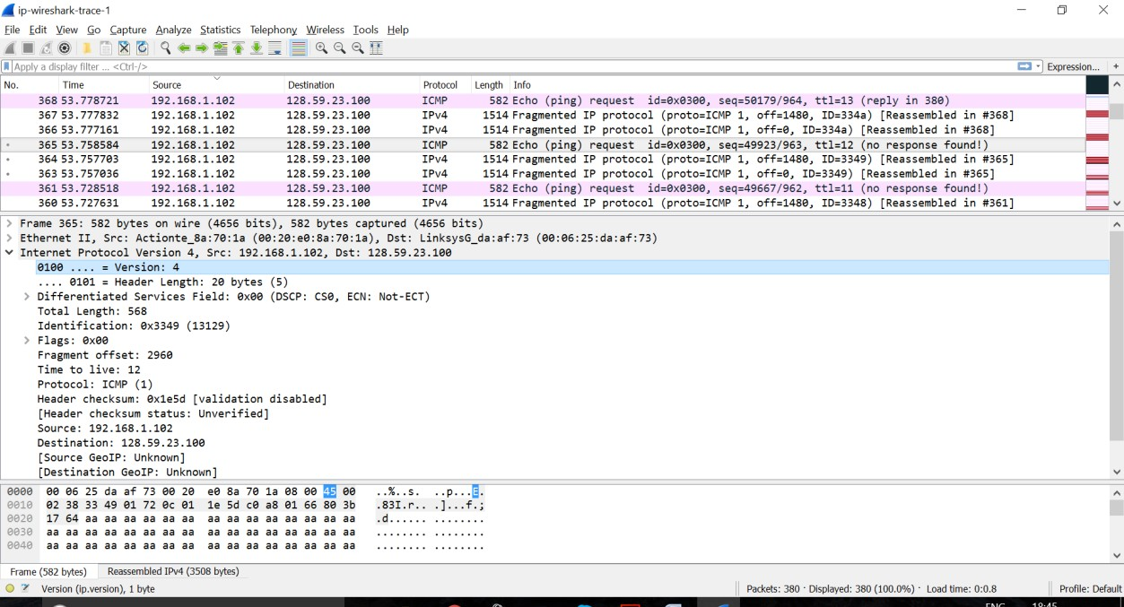

Datagram 361

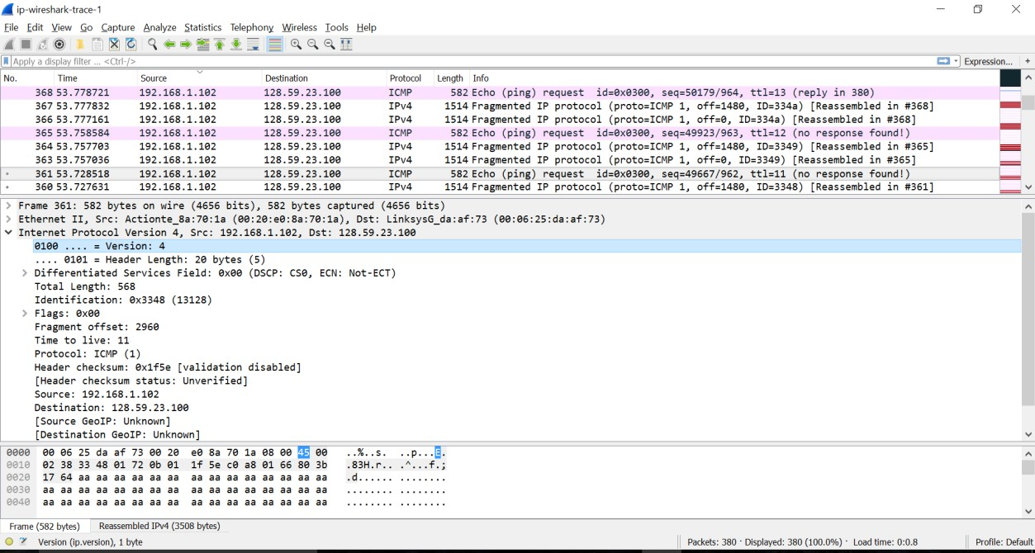

With the series of ICMP messages sent by the computer, the fields in the IP datagram that always change are identification, time to live and header checksum.

For datagram 368: Identification: 0x334a (13130)

Time to Live: 13

Header Checksum: 0x1d5c

For datagram 365: Identification: 0x3349 (13129)

Time to Live: 12

Header Checksum: 0x1e5d

For datagram 361:

Identification: 0x3348

(13128)

Time to Live: 11

Header Checksum: 0x1f5e

**6. Which fields stay constant? Which of the fields *must* stay constant? Which fields must change? Why?**

**Answer**:

The header length, payload length, flags, fragment offset, source address and destination address remain constant and must stay constant with the series of ICMP messages sent by the computer as the webpage is being accessed is the same.

The fields like identification, time to live and header checksum change with the series of ICMP messages sent to the computer as each packet should have a unique identification.

Datagram 368



Datagram 365



Datagram 361



**7. Describe the pattern you see in the values in the Identification field of the IP datagram Next (with the packets still sorted by source address) find the series of ICMP TTL exceeded replies sent to the computer by the nearest (first hop) router.**

**Answer**:

The value in the identification field of the IP datagram decreases by 1 as we move down.

Datagram 368



Datagram 365



Series of ICMP TTL exceeded replies sent to the computer

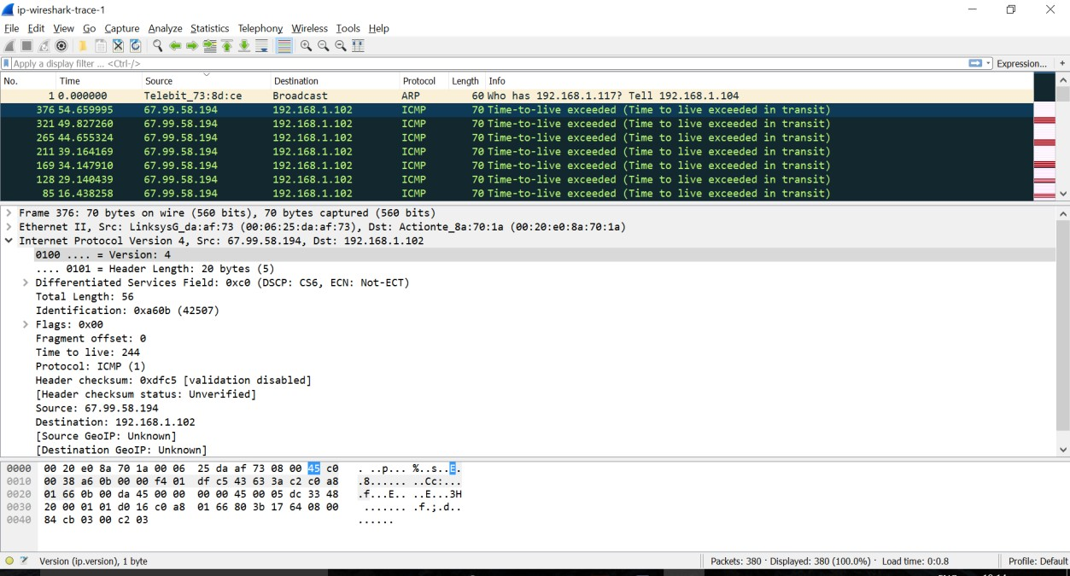

**8) What is the value in the Identification field and the TTL field?**

**Answer**:

Identification: 0xa60b (42507) Time to Live: 244

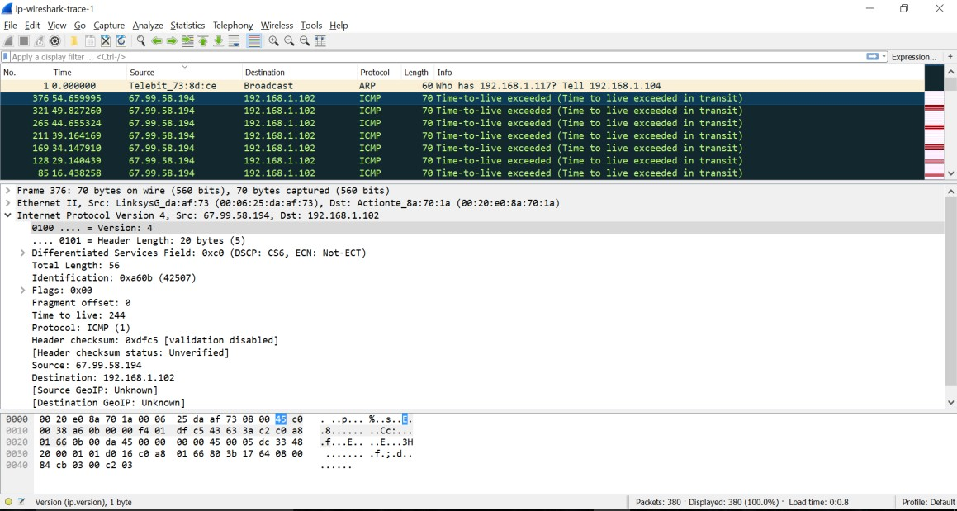

**9. Do these values remain unchanged for all of the ICMP TTL exceeded replies sent to the computer by the nearest (first hop) router? Why?**

**Answer:**

The identification value changes from one packet to another as each packet has unique identification, but the TTL values remain the same for the series of ICMP TTL exceeded replies sent to the computer as no datagram is sent to the computer.



